KUBERNETES – TASK -02
==============================================================================

- Create a Simple Pod Using YAML Task: Write a YAML file to create a Pod named firstpod with an nginx container. Verify the Pod creation using kubectl get pods and check the logs of the container using kubectl logs firstpod.

vi firstpod.yaml
apiVersion: v1
kind: Pod
metadata:
name: firstpod
spec:
containers:
- name: nginx-container
image: nginx
ports:
- containerPort: 80
Deploy
- kubectl apply -f firstpod.yaml
Verify
- kubectl get pods
Check Logs
- kubectl logs firstpod

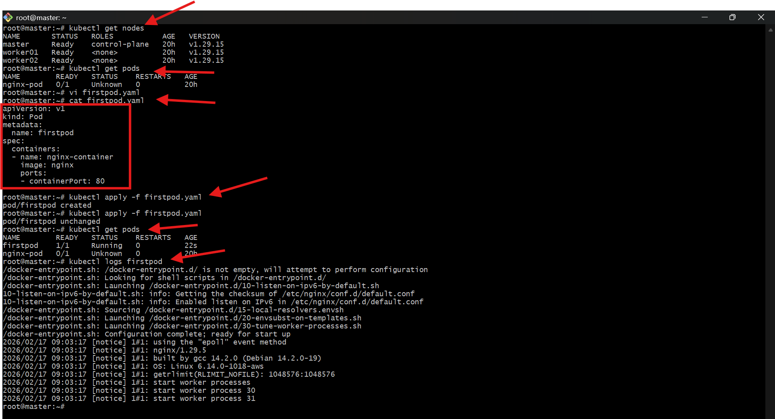

- Set Environment Variables in a Pod Task: Modify the YAML file to include environment variables myname: sabair and City: Hyderabad. Deploy the Pod and use kubectl exec <pod_name> -- env to check if the environment variables are set properly
vi firstpod-env.yaml
apiVersion: v1
kind: Pod
metadata:
name: firstpod-env
spec:
containers:
- name: nginx-container
image: nginx
env:
- name: myname
value: "sabair"
- name: City
value: "Hyderabad"
Deploy
- kubectl apply -f firstpod-env.yaml
Verify Environment Variables
- kubectl exec firstpod-env -- env
You should see:
myname=sabair
City=Hyderabad

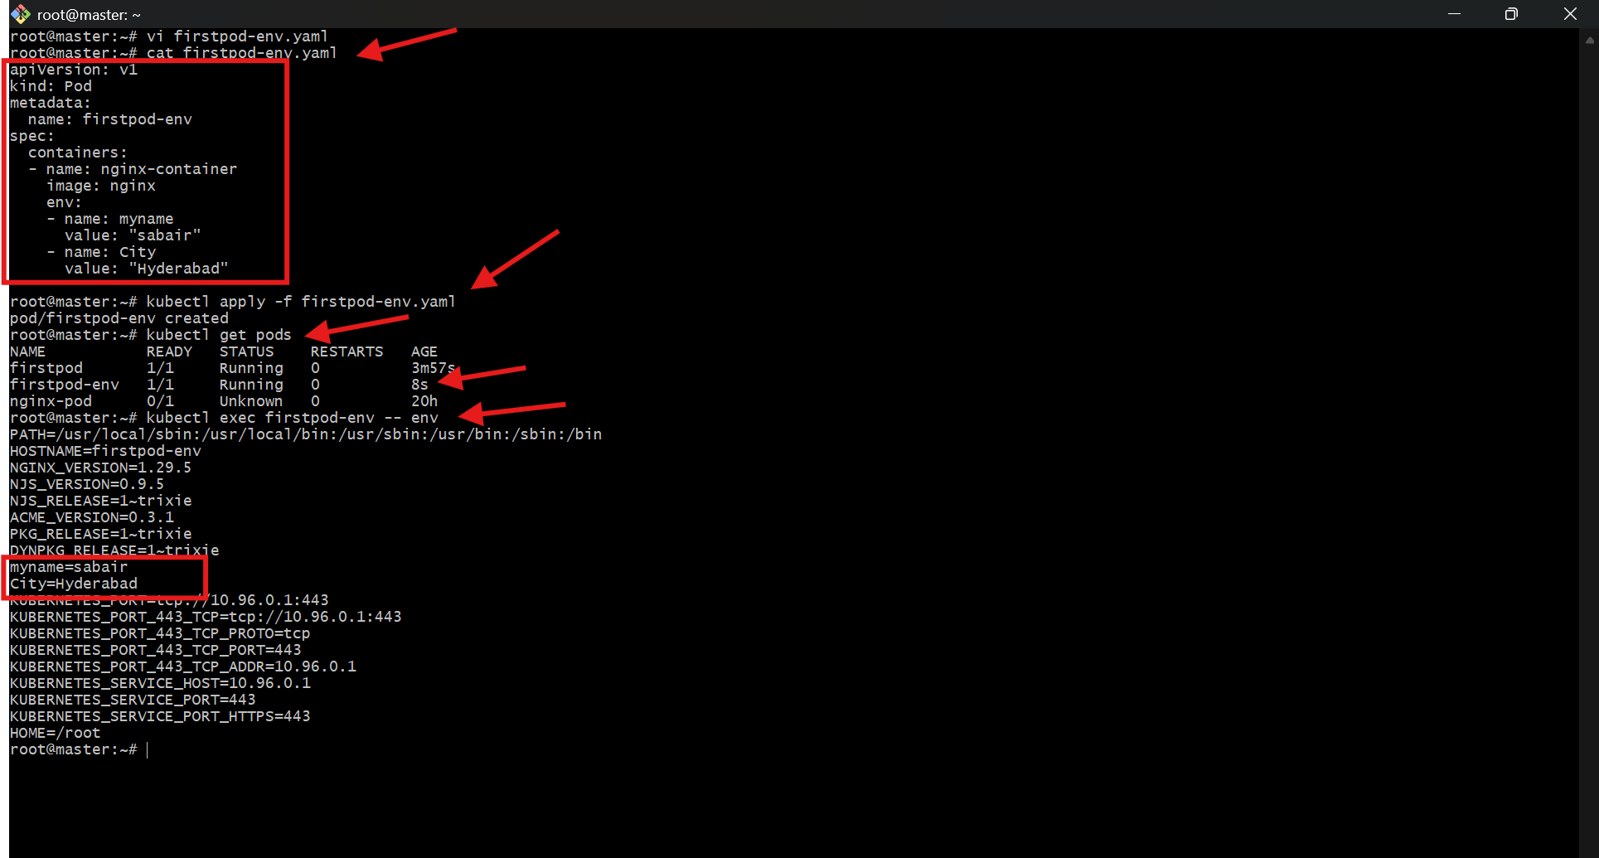

- Deploy a Pod with Commands (Args) in YAML Task: Modify the YAML file to add args that instruct the container to sleep for 50 seconds. Deploy the Pod and use kubectl describe pod to verify the args are correctly passed to the container

Vi firstpod-args.yaml
apiVersion: v1
kind: Pod
metadata:
name: sleep-pod
spec:
containers:
- name: nginx-container
image: busybox
args: ["sleep", "50"]
Deploy
- kubectl apply -f firstpod-args.yaml
Verify Args
- kubectl describe pod sleep-pod
Look under:
Containers:
Args:
sleep
50

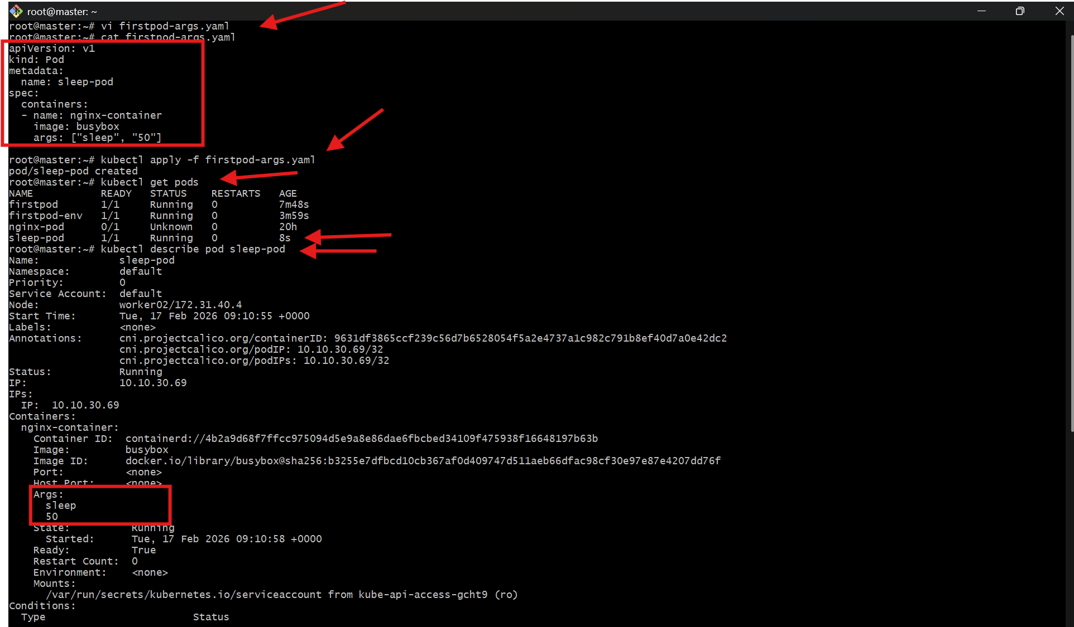

- Create a Pod with Two Containers Task: Create a YAML file to define a Pod with two nginx containers inside. Use kubectl exec to access both containers and verify that both containers can communicate through the same network (e.g., using telnet between them).

Vi twocontainer-pod.yaml
apiVersion: v1
kind: Pod
metadata:
name: two-nginx-pod-fixed
spec:
containers:
- name: nginx-1
image: nginx
ports:
- containerPort: 80

- name: nginx-2
image: nginx
command: ["/bin/sh"]
args:
- -c
- |
sed -i 's/listen 80;/listen 81;/' /etc/nginx/conf.d/default.conf && nginx -g 'daemon off;'
ports:
- containerPort: 81

Create the Pod
- kubectl apply -f twocontainer-pod.yaml
Verify
- kubectl get pods
You should see:
two-nginx-pod 2/2 Running

Test Container Communication
Exec into container 1:
- kubectl exec -it two-nginx-pod -c nginx-1 -- /bin/bash
(or /bin/sh if bash not available)
Now test nginx-2:
- curl localhost:81

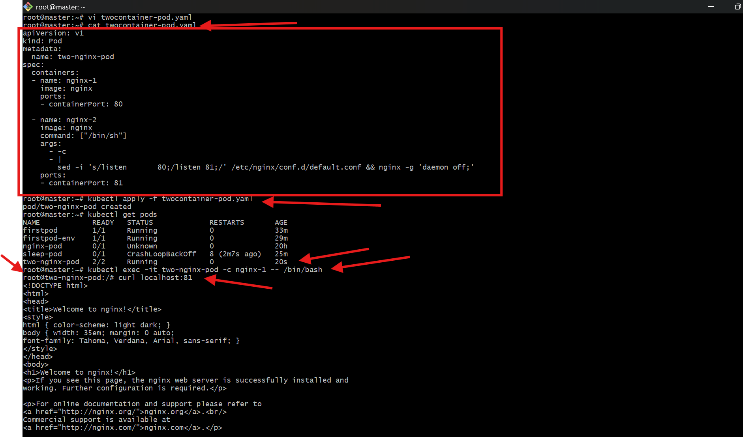

- Set Up an Init Container in a Pod Task: Modify the YAML to include an init container that sleeps for 30 seconds before the main containers start. Verify the init container's execution using kubectl describe pod and check the logs to confirm its completion.

vi initpod.yaml
apiVersion: v1
kind: Pod
metadata:
name: init-pod
spec:
initContainers:
- name: init-container
image: busybox
command: ["sh", "-c", "sleep 30"]

containers:
- name: nginx-container
image: nginx
Deploy
- kubectl apply -f initpod.yaml
Verify Init Container
- kubectl describe pod init-pod
Check:
Init Containers:
init-container:
State: Terminated
Reason: Completed
Check logs:
- kubectl logs init-pod -c init-container

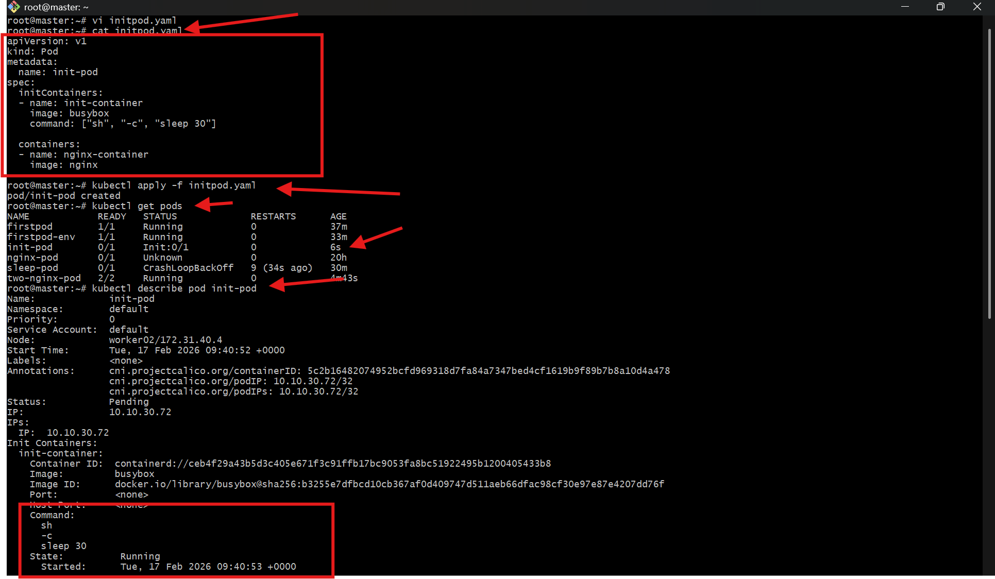

- Run a Dry Run Command to Generate YAML Task: Use the kubectl run nginx --image=nginx --dry-run=client -o yaml command to generate a Pod YAML definition. Modify the generated YAML to suit specific requirements (e.g., labels or environment variables) and deploy it.

- kubectl run nginx --image=nginx --dry-run=client -o yaml > nginx.yaml
- cat nginx.yaml
- change the file to
- vi nginx.yaml

apiVersion: v1
kind: Pod
metadata:
name: nginx
labels:
app: web
spec:
containers:
- name: nginx
image: nginx:1.25
ports:
- containerPort: 80
env:
- name: ENV
value: "production"

- kubectl apply -f nginx.yaml

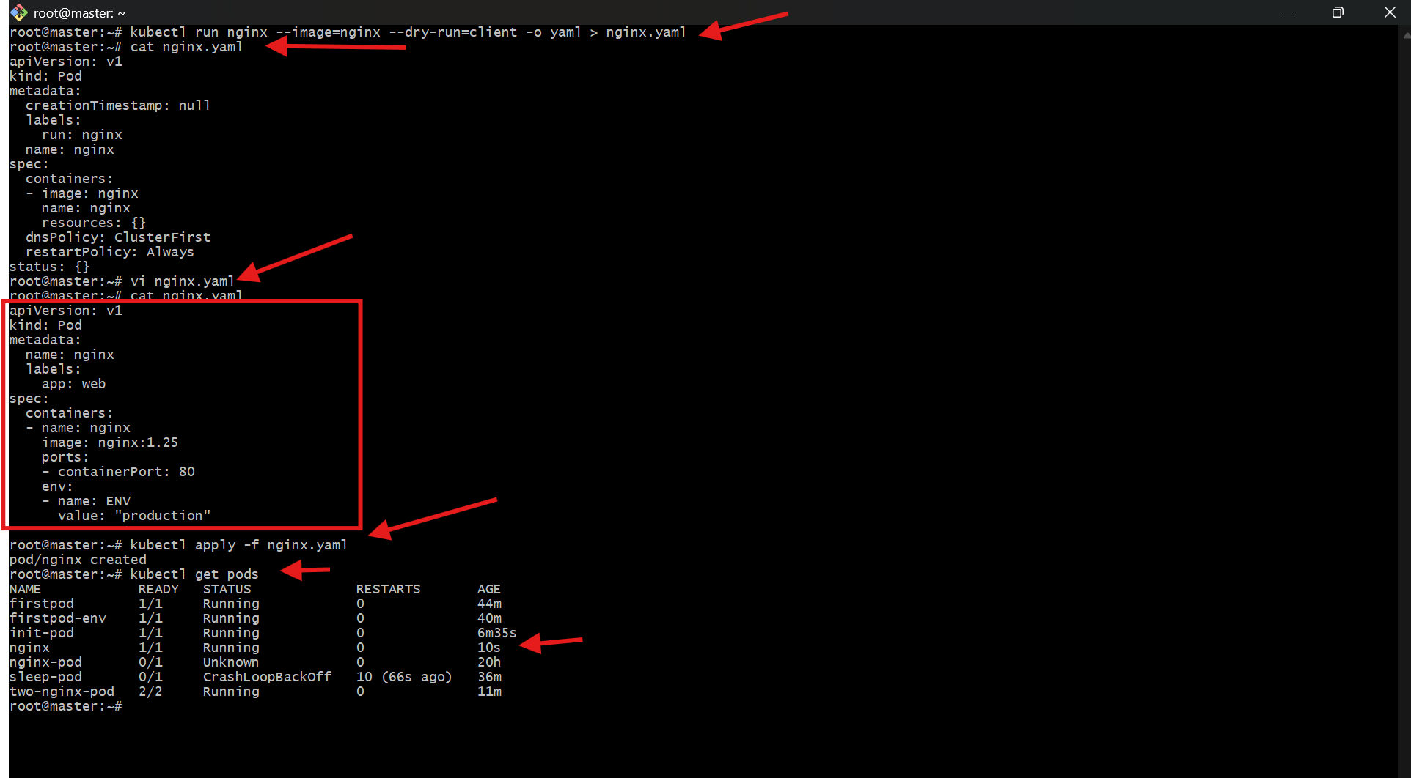

- Use kubectl apply vs kubectl create Task: Create a YAML file to define a Pod. First, deploy it using kubectl create -f <file_name>.yml and then modify the YAML (e.g., change the image version). Use kubectl apply to redeploy and verify the difference between both commands.

Step 1 – Create Pod
- kubectl create -f firstpod.yaml
If you run again → it fails (Already exists)

Step 2 – Modify YAML (Change Image)
Change:
- image: nginx:1.25
Now use:
- kubectl apply -f firstpod.yaml
apply updates existing resource
create only creates new resources
Verify:
- kubectl describe pod firstpod

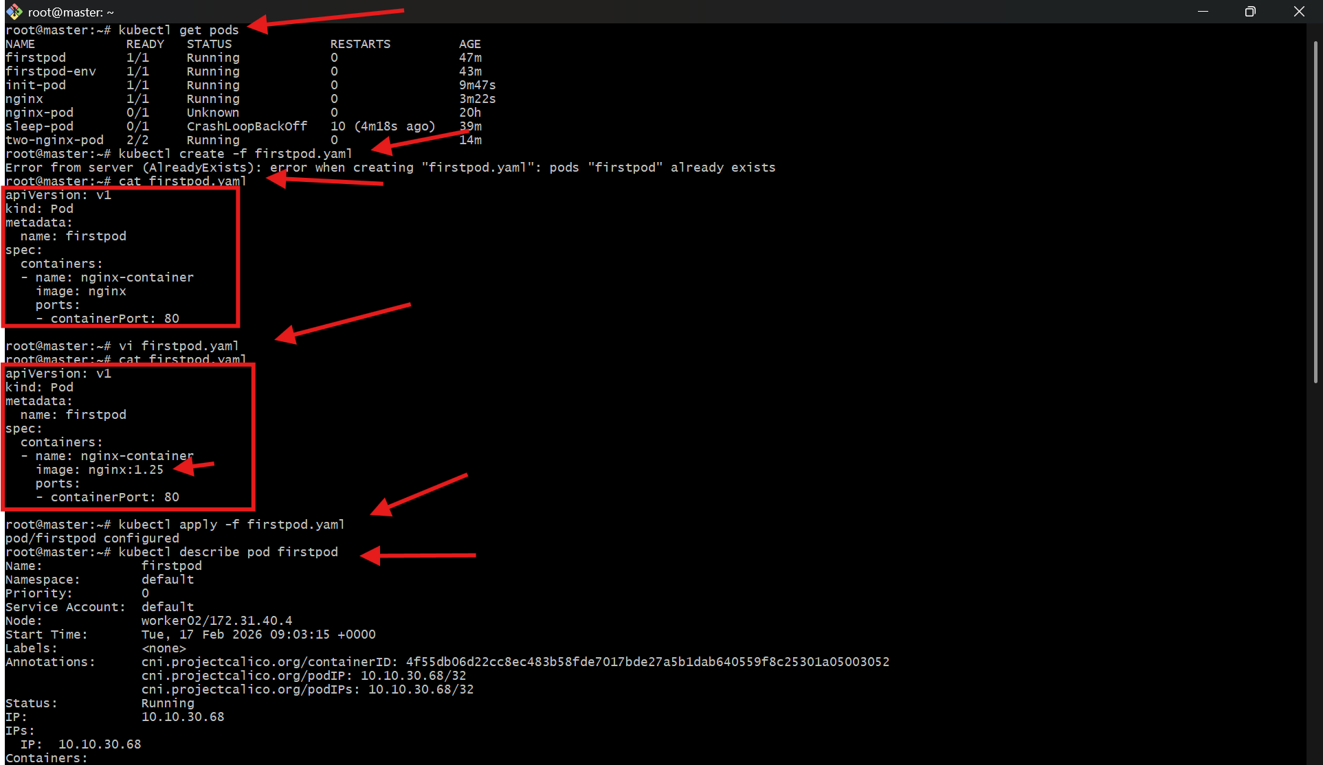

- Edit an Existing Pod Configuration Task: Use kubectl edit pod <pod_name> to modify the running Pod's environment variables or image. After making the changes, verify if they took effect by checking the container logs or environment variables using kubectl exec.

Edit Running Pod
- kubectl edit pod firstpod
Modify image or env variables.
⚠️ Important:
Some fields (like image) are editable.
Some changes require Pod recreation.
Verify:
- kubectl describe pod firstpod
- kubectl exec firstpod -- env

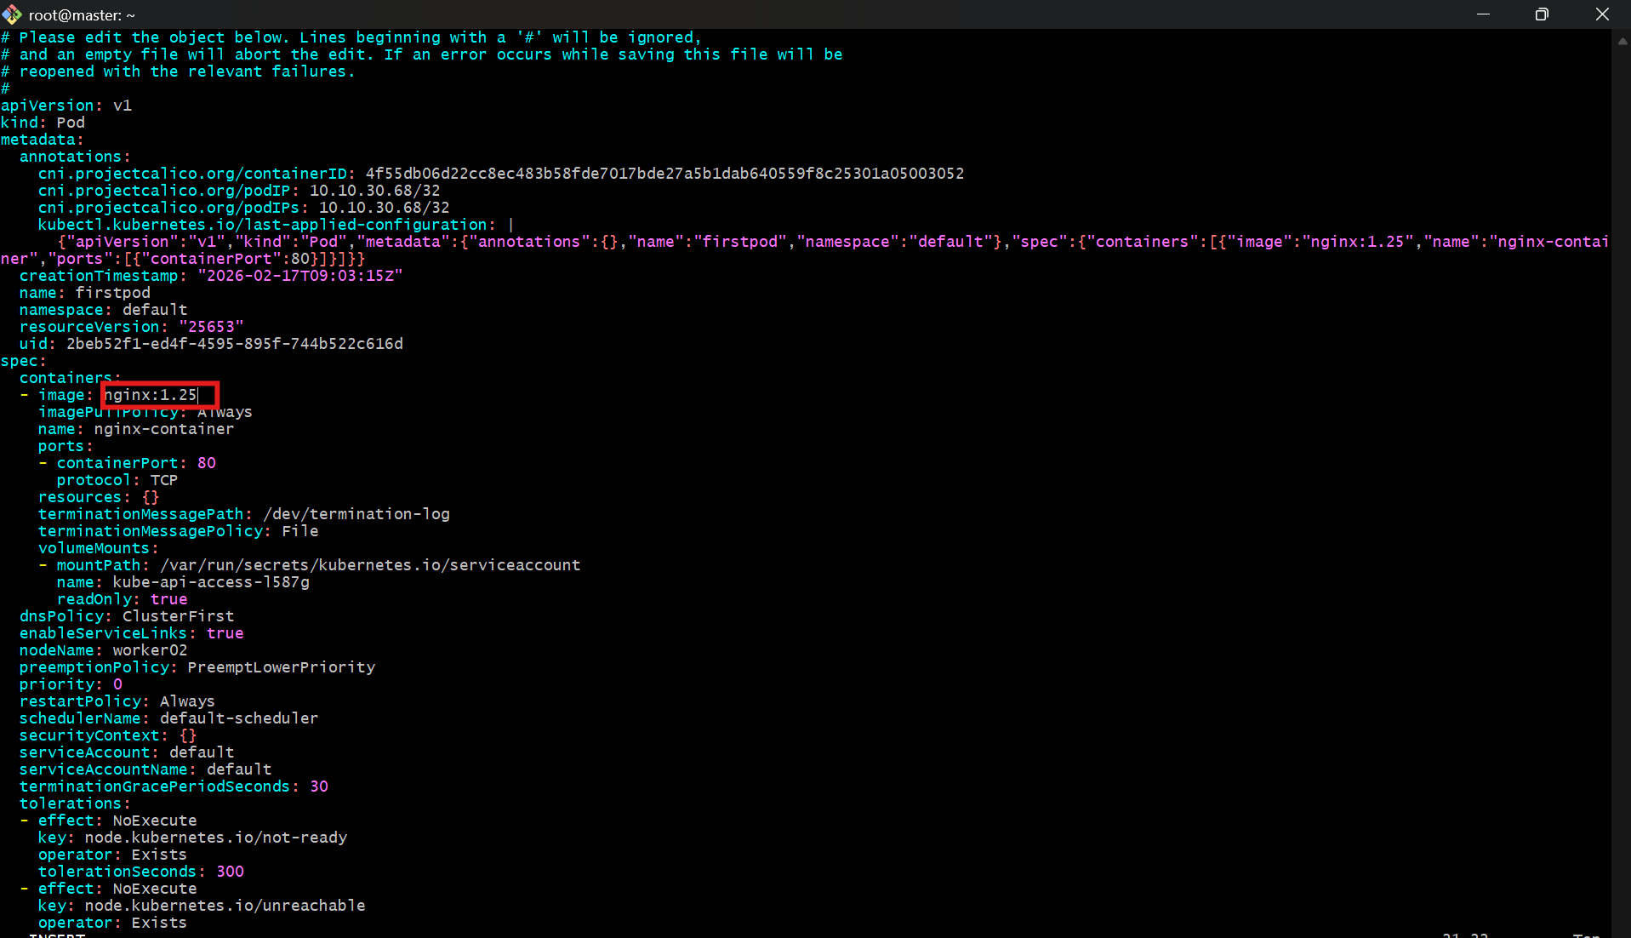

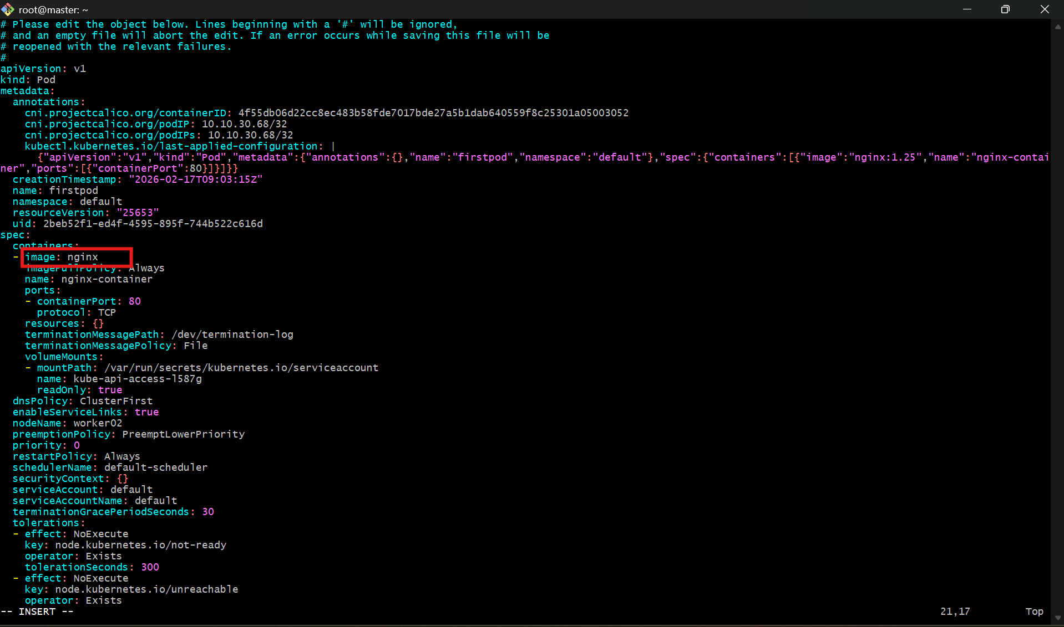

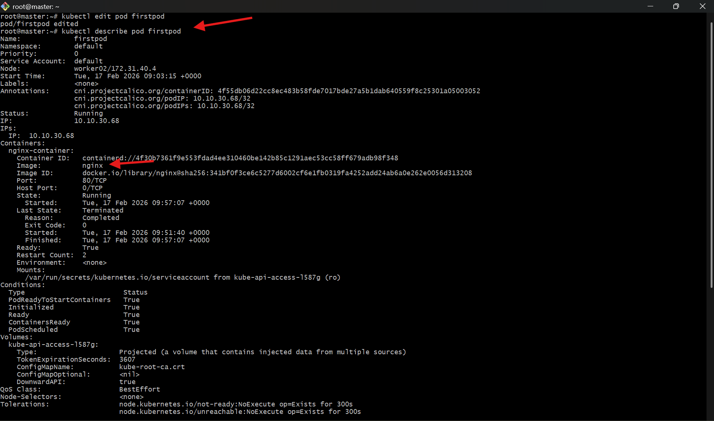

- Expose a Pod Using a Service Task: Create a YAML file to expose your firstpod using a Service (ClusterIP). Ensure that your service is exposing the Pod on port 80 and verify it using kubectl get svc.
Vi service.yaml

apiVersion: v1

kind: Service

metadata:

name: firstpod-service

spec:

type: ClusterIP

selector:

app: web

ports:

- port: 80

targetPort: 80

⚠️ Make sure your Pod has:

labels:

app: web

Deploy
- kubectl apply -f service.yaml

Verify
- kubectl get svc

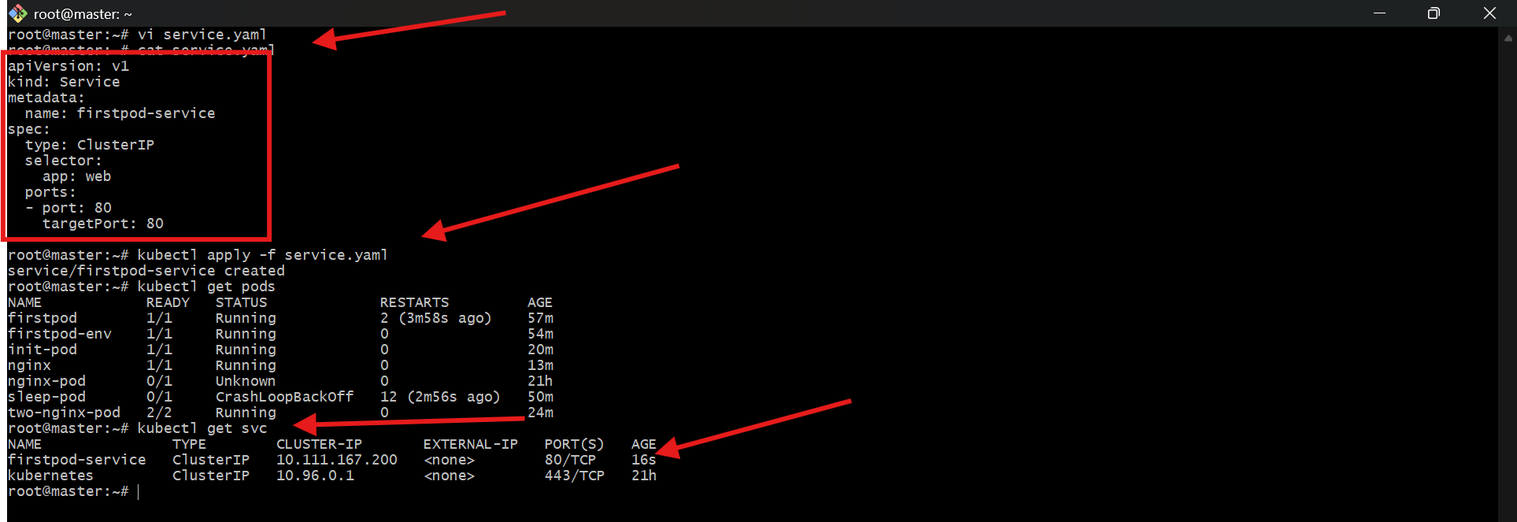

- Pod with Resource Limits and Requests Task: Add resource requests and limits to the containers in your YAML file. Specify CPU and memory requests/limits for both containers and deploy the Pod. Use kubectl describe pod to verify if the resource configurations are correctly applied.

Vi resource-pod.yaml
apiVersion: v1
kind: Pod
metadata:
name: resource-pod
spec:
containers:
- name: nginx-1
image: nginx
resources:
requests:
memory: "64Mi"
cpu: "250m"
limits:
memory: "128Mi"
cpu: "500m"

- name: nginx-2
image: nginx
resources:
requests:
memory: "64Mi"
cpu: "200m"
limits:
memory: "128Mi"
cpu: "400m"
Deploy
- kubectl apply -f resource-pod.yaml
Verify
- kubectl describe pod resource-pod
Look under:
- Limits:
cpu: 500m
memory: 128Mi
Requests:
cpu: 250m
memory: 64Mi

